Pipeline Jobs Assignment

1. Create 3 ec2-instance like One master and two slave

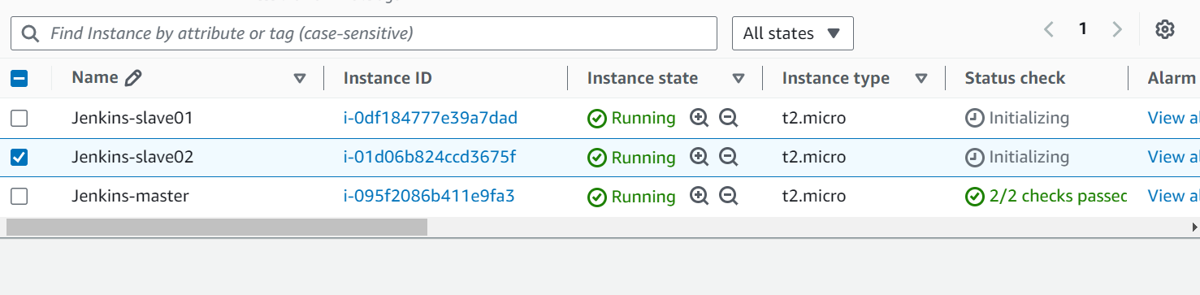

1. Login master and install java, Jenkins and maven
2. Once Jenkins open configure both slave through SSH.

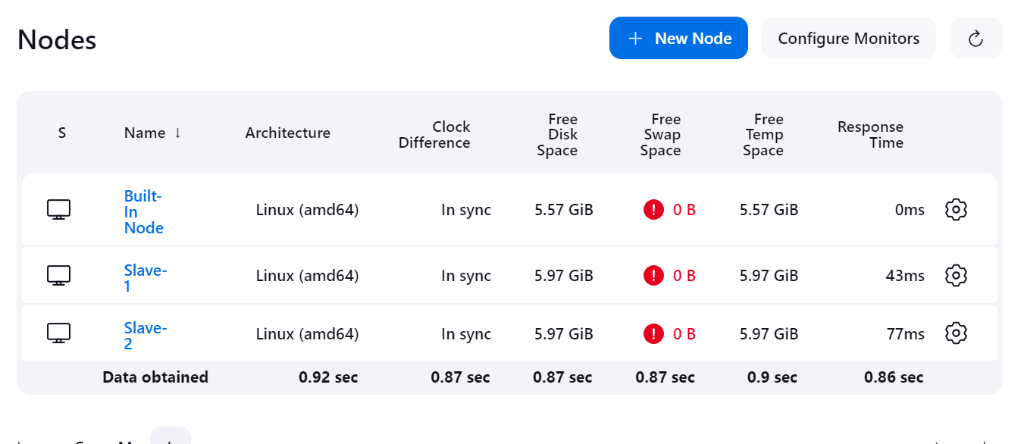

1. On both slave install java and apach-tomact
2. After that on master create private key file.
3. On slave give full permission of /mnt folder .and manually copy one file from master

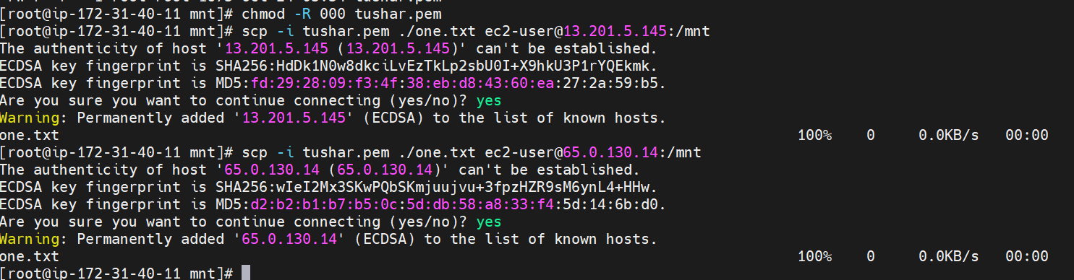

1. Now create groovy Jenkins’s pipeline
2. pipeline{
3. agent{
4. label {
5. label "built-in"
6. }
7. }
8. stages{
9. stage("clone github"){
10. steps{
11. sh '''
12. cd /mnt
13. git clone https://github.com/jidnyasactc/loginwebapp.git
14. '''
15. }
16. }
17. stage("maven install"){
18. steps{
19. sh '''
20. cd /mnt/loginwebapp/
21. mvn clean install
22. '''
23. }
24. }
25. stage("deploy"){
26. steps{
27. sh "scp -i /mnt/tushar.pem /mnt/loginwebapp/target/LoginWebApp.war ec2-user@65.0.130.14:/mnt/server/apache-tomcat-9.0.96/webapps"
28. sh "scp -i /mnt/tushar.pem /mnt/loginwebapp/target/LoginWebApp.war ec2-user@13.201.5.145:/mnt/server/apache-tomcat-9.0.96/webapps"
29. }
30. }
31. }
32. }

9. create one new project 🡪 Pipeline🡪 Pipeline script

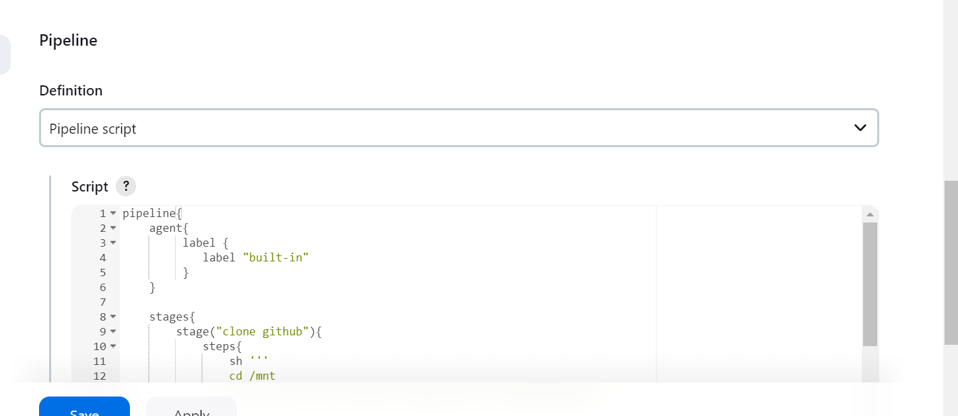

10. then build now and check console output

Started by user [Tushar Chavan](http://13.127.99.182:8080/jenkins/user/412tushar)

[Pipeline] Start of Pipeline

[Pipeline] node

Running on [Jenkins](http://13.127.99.182:8080/jenkins/computer/(built-in)/) in /root/.jenkins/workspace/time

[Pipeline] {

[Pipeline] stage

[Pipeline] { (clone github)

[Pipeline] sh

+ cd /mnt

+ git clone <https://github.com/jidnyasactc/loginwebapp.git>

Cloning into 'loginwebapp'...

[Pipeline] }

[Pipeline] // stage

[Pipeline] stage

[Pipeline] { (maven install)

[Pipeline] sh

+ cd /mnt/loginwebapp/

+ mvn clean install

NOTE: Picked up JDK_JAVA_OPTIONS: --add-opens=java.base/java.lang=ALL-UNNAMED --add-opens=java.base/java.io=ALL-UNNAMED --add-opens=java.base/java.util=ALL-UNNAMED --add-opens=java.base/java.util.concurrent=ALL-UNNAMED --add-opens=java.rmi/sun.rmi.transport=ALL-UNNAMED

[INFO] Scanning for projects...

[INFO]

[INFO] --------------------< com.javawebtutor:LoginWebApp >--------------------

[INFO] Building LoginWebApp Maven Webapp 1.0-SNAPSHOT

[INFO] from pom.xml

[INFO] --------------------------------[ war ]---------------------------------

[INFO]

[INFO] --- clean:3.2.0:clean (default-clean) @ LoginWebApp ---

[INFO]

[INFO] --- resources:3.3.1:resources (default-resources) @ LoginWebApp ---

[WARNING] Using platform encoding (UTF-8 actually) to copy filtered resources, i.e. build is platform dependent!

[INFO] skip non existing resourceDirectory /mnt/loginwebapp/src/main/resources

[INFO]

[INFO] --- compiler:3.13.0:compile (default-compile) @ LoginWebApp ---

[INFO] No sources to compile

[INFO]

[INFO] --- resources:3.3.1:testResources (default-testResources) @ LoginWebApp ---

[WARNING] Using platform encoding (UTF-8 actually) to copy filtered resources, i.e. build is platform dependent!

[INFO] skip non existing resourceDirectory /mnt/loginwebapp/src/test/resources

[INFO]

[INFO] --- compiler:3.13.0:testCompile (default-testCompile) @ LoginWebApp ---

[INFO] No sources to compile

[INFO]

[INFO] --- surefire:3.2.5:test (default-test) @ LoginWebApp ---

[INFO] No tests to run.

[INFO]

[INFO] --- war:3.4.0:war (default-war) @ LoginWebApp ---

[INFO] Packaging webapp

[INFO] Assembling webapp [LoginWebApp] in [/mnt/loginwebapp/target/LoginWebApp]

[INFO] Processing war project

[INFO] Copying webapp resources [/mnt/loginwebapp/src/main/webapp]

[INFO] Building war: /mnt/loginwebapp/target/LoginWebApp.war

[INFO]

[INFO] --- install:3.1.2:install (default-install) @ LoginWebApp ---

[INFO] Installing /mnt/loginwebapp/pom.xml to /root/.m2/repository/com/javawebtutor/LoginWebApp/1.0-SNAPSHOT/LoginWebApp-1.0-SNAPSHOT.pom

[INFO] Installing /mnt/loginwebapp/target/LoginWebApp.war to /root/.m2/repository/com/javawebtutor/LoginWebApp/1.0-SNAPSHOT/LoginWebApp-1.0-SNAPSHOT.war

[INFO] ------------------------------------------------------------------------

[INFO] BUILD SUCCESS

[INFO] ------------------------------------------------------------------------

[INFO] Total time: 5.165 s

[INFO] Finished at: 2024-10-24T07:28:47Z

[INFO] ------------------------------------------------------------------------

[Pipeline] }

[Pipeline] // stage

[Pipeline] stage

[Pipeline] { (deploy)

[Pipeline] sh

+ scp -i /mnt/tushar.pem /mnt/loginwebapp/target/LoginWebApp.war ec2-user@65.0.130.14:/mnt/server/apache-tomcat-9.0.96/webapps

[Pipeline] sh

+ scp -i /mnt/tushar.pem /mnt/loginwebapp/target/LoginWebApp.war ec2-user@13.201.5.145:/mnt/server/apache-tomcat-9.0.96/webapps

[Pipeline] }

[Pipeline] // stage

[Pipeline] }

[Pipeline] // node

[Pipeline] End of Pipeline

Finished: SUCCESS

11. hit the Public IP address of slave

<http://65.0.130.14:8080/LoginWebApp/>

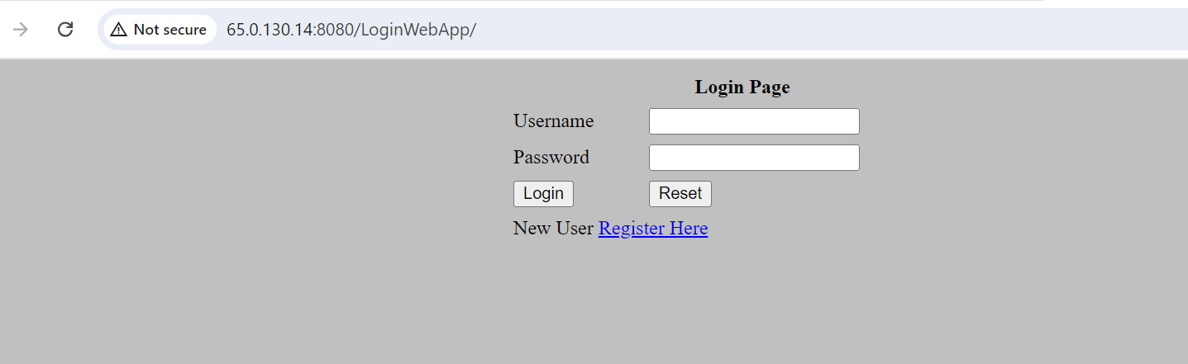

<http://13.201.5.145:8080/LoginWebApp/>

